Summary
Beazley is a global leader in cyber insurance, offering a comprehensive and dynamic solution called Full Spectrum Cyber, designed to address the full lifecycle of cyber risk. With over 20 years of expertise, Beazley’s approach goes beyond traditional insurance by integrating risk management, incident response, and proactive prevention
Beazley Insurance is developing a seamless digital underwriting and finance platform built on a sophisticated Event Driven Architecture (EDA). In this model, multiple loosely coupled components communicate asynchronously through events, which introduces significant complexity in tracing data flows. To address the unique testing challenges of EDA, Beazley partnered with Capgemini. The test team strategically leveraged modern technologies and techniques; including mocking, event sourcing, observability, effective use of Kafka controls, Datadog, AI-based data generation, and data ingestion tools; alongside traditional test automation. This ensured robust and reliable system validation to support the release plan to deliver desired business outcomes
Beazley offers a diverse portfolio of insurance products across the globe, including:
- D&O – Directors and Officers Liability
- EPL – Employment Practices Liability
- Fiduciary Liability Insurance
- Professional Civil Liability Insurance
- Cyber Insurance & Cyber Services
- BBR – Beazley Breach Response 2.0 & 5.0
- IMI – Investment Management Insurance
- FIPI – Financial Institution Professional Indemnity Insurance

Currently, the onboarding process for these products is manual. The proposed solution will fully automate this process by leveraging cutting-edge technologies and AI, enhancing efficiency, scalability, and user experience across all regions.
Testing Challenges in the Program
This program faced several complex testing challenges due to its scale, architecture, and multi-vendor setup:
- Environment Constraints: Critical external systems like the London Market and HX Rate were not accessible in test environments due to security restrictions, limiting end-to-end testing capabilities.
- Multi-Vendor Coordination: With multiple vendors involved globally, coordination across teams added significant complexity.
- Test Data Limitations: There was no production-like test data, no Test Data Management (TDM) solution for data masking, and no capability for on-demand data provisioning. Reference data consistency was essential across all integrated systems, particularly for entities such as broker details. The event-driven architecture complicated test data injection, as data had to be introduced externally rather than directly into databases
- Technology Stack Complexity: The solution spans multiple layers and technologies, including:
  - Multi-cloud environments – Azure and AWS
  - Event-driven, asynchronous architecture
  - Kafka, Guidewire, and off-the-shelf products like Insight, BI Reporting, and Finance Systems
- Monitoring Challenges: Each technology introduced unique monitoring and observability challenges.
- Legacy Integration: New application layers were tightly integrated with legacy systems, increasing the risk and complexity of testing.
- Delivery Pressure: The program operated under extremely tight timelines and high delivery pressure, requiring rapid execution and adaptability

Test Solution Architecture

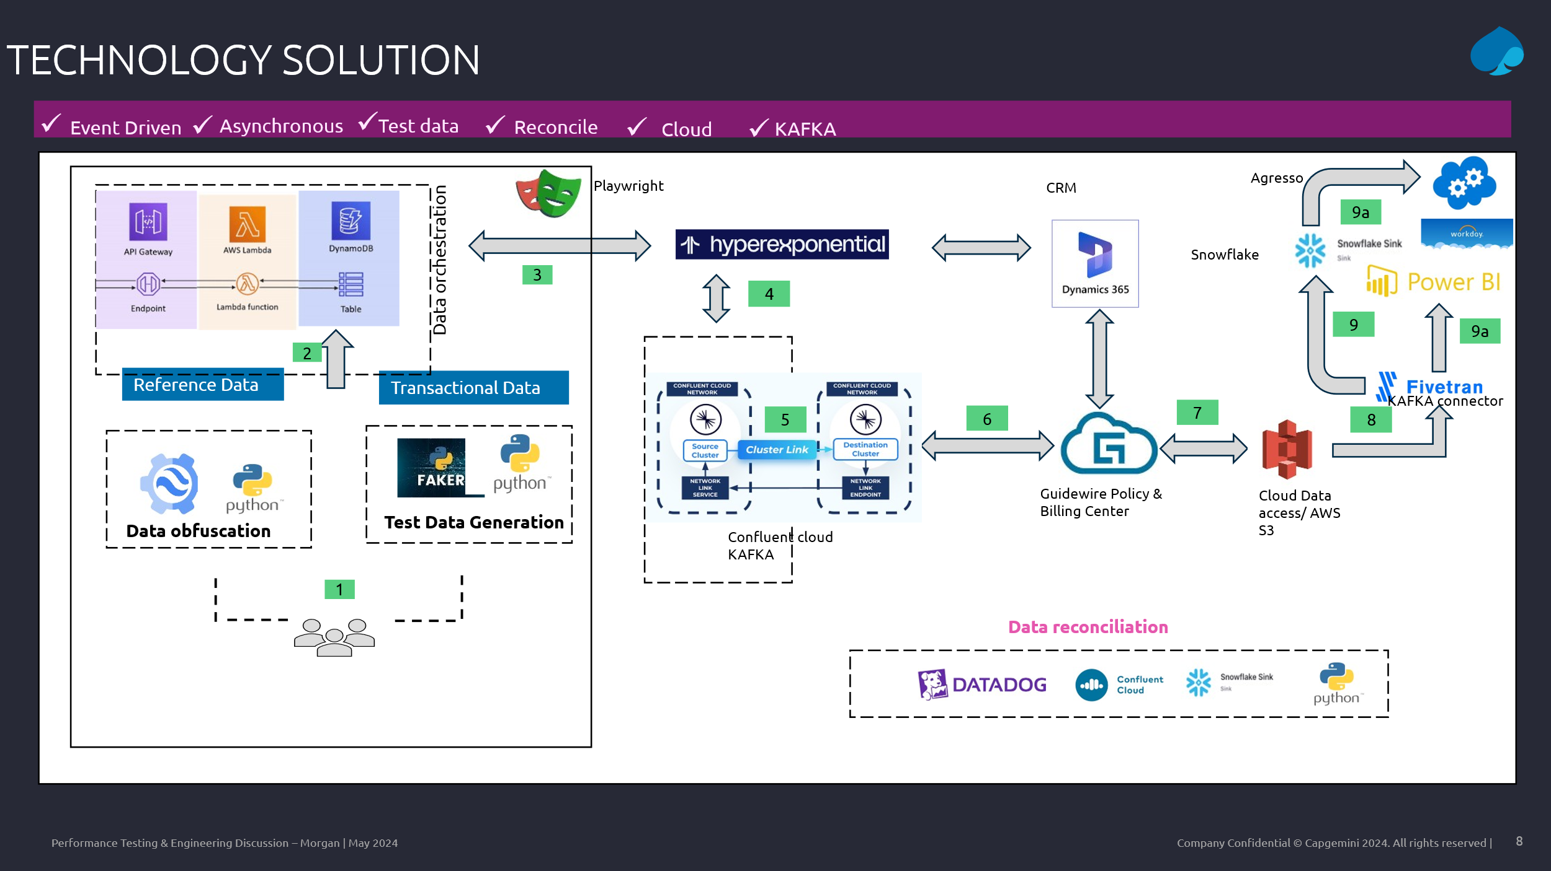
A comprehensive test data solution was implemented to support end-to-end testing, validation, and reconciliation across a distributed ecosystem. The architecture spans reference data management, synthetic data generation, orchestration, event-driven integration, and observability.

Reference Data Management
Reference data was identified across all relevant source systems and centralized in Amazon DynamoDB. Systems requiring reference data make direct calls to DynamoDB, ensuring consistency and eliminating duplication.

Synthetic Transactional Data Generation
Transactional data was generated using Python Faker, which seamlessly inserts synthetic records into DynamoDB. This approach supports scalable, production-safe testing without reliance on sensitive or real-world data.

Test Data Orchestration
Orchestration was achieved using Playwright, which automates the insertion of data into the source system—Insight, representing the underwriter application. Once an event is created in Insight, it is published to Confluent Kafka, where the data enrichment process is triggered.

Event Consumption and Integration
Enriched events are made available on a public Kafka cluster, from which downstream consumers retrieve them. The primary consumer is Guidewire PolicyCenter (PC), integrated via a custom Integration Gateway.
The gateway performs validation on incoming events:
- Failed validations are routed to an exception queue in AWS S3, enabling traceability and audit.
- Successful validations are forwarded to Guidewire PolicyCenter for policy processing.
Post-processing includes replication of policy details into Guidewire BillingCenter, ensuring data consistency across core systems.

Event Publishing and Downstream Consumption
Once Guidewire completes processing, the Integration Gateway publishes the updated event back to a Kafka topic, enabling other systems to react to the updated status.
These messages are also made available via Cloud Data Access (CDA). A Fivetran Kafka connector pulls messages from CDA every 15 minutes and loads them into Snowflake.
- Reconciliation in Snowflake: A Snowflake dashboard was created to verify records based on policy number, ensuring alignment between Kafka events and Snowflake ingestion.
- Downstream Consumers:
  - Finance Systems (e.g., Agresso) consume messages from Snowflake for final settlement.
  - Business Intelligence (BI) Reports also consume the same messages for analytics and operational reporting.

Data Reconciliation and Observability
To ensure data integrity and traceability across the pipeline, multiple reconciliation and monitoring mechanisms were implemented:
- Insight Database Validation: A custom Python script queries the Insight database to count the number of events created within a specific time window.
- Kafka Message Verification: Kafka message counts were verified using Confluent Control Center and a dedicated Python script that retrieves total message counts from relevant topics.
- Guidewire Event Tracking: Integration Gateway and Guidewire PC event processing were monitored using DataDog logs. A tailored dashboard tracks specific log patterns aligned with event IDs, enabling real-time visibility.
- Exception Handling in AWS S3: A Python script was developed to:
  - Count the number of failed validation events stored in the S3 bucket.
  - Download and inspect exception messages for root cause analysis.
- Snowflake Reconciliation: Records were verified in Snowflake using policy numbers, ensuring consistency between Kafka events and Snowflake ingestion.

The testing strategy has primarily followed a risk-based approach, involving multiple vendors collaborating across different levels and geographies. While risk-based testing has been the foundation, Capgemini has enhanced coverage by incorporating API testing and template-based testing.
To automate critical user journeys, Playwright has been employed effectively. However, to validate the broader spectrum of permutations and combinations, Guidewire APIs have been extensively utilized, ensuring comprehensive functional coverage and robustness.

TBD
Project Target / Achievements
TBD

What does the future hold?
TBD

